Nova-MW3 How to use blacklist feature?
This article will guide you how to remove a device from blacklist and the steps as below.

Step1: Open Tenda WiFi APP and tap “Connected Devices”.

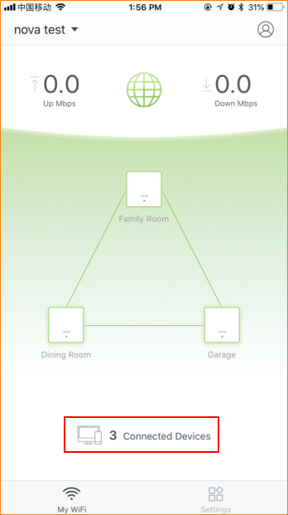
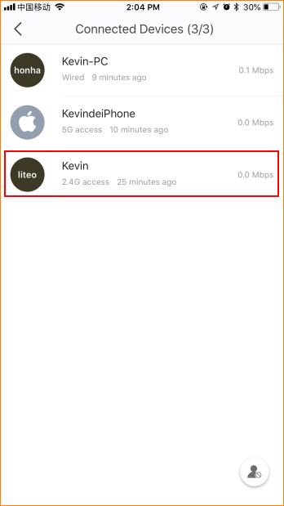

Step2: Select device which you want to block and tap “Add to Blacklist”.

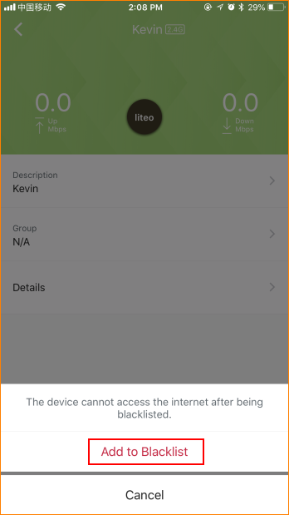

Step3: Tap gray head icon in the lower right corner and tap “Remove All Devices”.

